Activity
Case Analysis – Avoiding Misleading Proportions
Question 1: Truncated Y-Axis in Sales Growth
A retail company presents the following monthly sales (in ₹ lakhs):
Month Sales
January 95
February 97
March 99
April 101
May 103
June 105

The marketing team creates a bar chart with the Y-axis starting at 90 instead of 0. The chart visually suggests that June sales are almost twice those of January.
Tasks:
1. Explain why the chart is misleading.
2. Identify the visualization principle that has been violated.
3. Recommend an improved visualization method.
4. Describe how this misleading chart could influence business decisions.

1. Why is the chart misleading?
The bar chart is misleading because the Y-axis starts at ₹90 lakhs instead of ₹0. This makes the small difference between January sales (₹95 lakhs) and June sales (₹105 lakhs) appear much larger than it actually is.
- January sales = ₹95 lakhs
- June sales = ₹105 lakhs
- Actual increase = ₹10 lakhs
- Percentage increase = 10.53%
However, because the chart starts at ₹90 lakhs, the visual bar heights are approximately:
- January: 95 − 90 = 5 units
- June: 105 − 90 = 15 units
Thus, June's bar appears three times as tall as January's, even though actual sales increased by only about 10.53%. The visual impression can therefore falsely suggest dramatic growth.

2. Visualization principle violated
The chart violates the zero-baseline principle, particularly for bar charts.
Bar charts should normally begin at zero because the length of the bars represents the magnitude of the values.
Truncating the Y-axis exaggerates differences and can distort the viewer's perception of the data.

3. Recommended improved visualization method
A better approach is to use a bar chart with the Y-axis starting at ₹0 lakhs.
Alternatively, a line chart can be used to show the monthly sales trend. If the purpose is to emphasize the relatively small growth, the chart should clearly indicate the scale and the truncated axis rather than making the difference appear disproportionately large.
With a zero-based bar chart, the sales would correctly show a gradual increase:
₹95 → ₹97 → ₹99 → ₹101 → ₹103 → ₹105 lakhs

4. How could this influence business decisions?
The misleading chart could cause managers to overestimate sales growth and make inappropriate decisions. For example:
- They may assume that sales have increased dramatically.
- The company might increase production or inventory unnecessarily.
- Management may allocate excessive marketing budgets based on the perceived growth.
- Sales teams could receive unrealistic targets.
- The company might invest in expansion based on an exaggerated perception of performance.
Therefore, misleading visualization can result in incorrect interpretation of business performance and poor decision-making.

Conclusion
The chart exaggerates a relatively small 10.53% increase in sales by using a truncated Y-axis. Following the zero-baseline principle and using an appropriate bar or line chart would present the data more accurately and support reliable business decisions.

Question 2: Pie Chart with Incorrect Proportions
A university reports student enrollment in four departments.
Department Students
Computer Science 420
Electronics 280
Mechanical 200
Civil 100
The designer accidentally creates a pie chart where the slices occupy approximately 50%, 30%, 15%, and 15% instead of the correct proportions.
Tasks:
1. Calculate the correct percentage for each department.
2. Explain why the displayed chart is misleading.
3. Suggest an alternative chart that would improve comparison accuracy. 4. Discuss how such errors could affect institutional planning.

Given Data
Department | Students
Computer Science | 420
Electronics | 280
Mechanical | 200
Civil | 100
Total | 1000

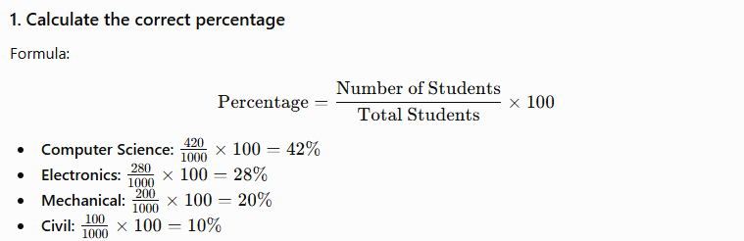

Department | Students | Correct Percentage
Computer Science | 420 | 42%
Electronics | 280 | 28%
Mechanical | 200 | 20%
Civil | 100 | 10%
Total | 1000 | 100%

2. Why is the displayed chart misleading?
The designer has shown the slices as approximately 50%, 30%, 15%, and 15%, which does not match the actual enrollment proportions of 42%, 28%, 20%, and 10%.
The most serious issue is that the incorrect percentages add up to:
50+30+15+15=110%
A pie chart must always represent 100% of the data. Therefore, the displayed chart gives viewers an incorrect impression of the relative size of each department.
For example, Civil actually represents only 10%, but the chart shows it as approximately 15%, making Civil appear to have more students than it actually does.

3. Alternative chart for better comparison
A bar chart would be a better choice because it allows users to compare the enrollment numbers directly.
For example:
- Computer Science → 420
- Electronics → 280
- Mechanical → 200
- Civil → 100
A bar chart makes differences between departments easier to identify than pie-slice angles and areas.

4. Effect on institutional planning
Incorrect visualization can lead to poor institutional decisions. University administrators may:
- Allocate too many classrooms or faculty to departments that appear larger.
- Underestimate resources needed by departments that appear smaller.
- Make incorrect decisions about laboratory facilities and equipment.
- Misallocate budgets and staff.
- Set inappropriate admission targets for different departments.
- Make inaccurate long-term infrastructure plans.

Conclusion
The correct enrollment distribution is 42% Computer Science, 28% Electronics, 20% Mechanical, and 10% Civil. The incorrect pie chart exaggerates or understates department sizes and can therefore lead to misinterpretation and improper resource allocation. A bar chart would provide a more accurate and easier comparison.
Question 3: Unequal Bar Widths in Revenue Comparison
A software company compares annual revenue.
Product Revenue (₹ Crores)
A 60
B 75
C 90
D 105
Instead of using equal-width bars, the designer creates bars with increasing widths, making Product D appear nearly three times larger than Product A.
Tasks:
1. Identify the graphical error.
2. Explain how unequal bar widths distort perception.
3. Redesign the visualization by specifying the correct design principles. 4. Discuss the possible consequences if investors rely on this chart.

1. Identify the graphical error
The graphical error is the use of unequal bar widths for comparing products.
In a standard bar chart, all bars should have the same width. The only visual difference should be their height, which represents the revenue value.
The correct revenues are:
Product | Revenue (₹ Crores)
A | 60
B | 75
C | 90
D | 105

2. How do unequal bar widths distort perception?
Unequal widths make viewers perceive both height and area as representing the data. Since Product D has a much wider bar than Product A, its visual area becomes disproportionately larger.
Although Product D's actual revenue is: 1.75
So D's revenue is 1.75 times A's revenue, not three times.
Increasing the bar width can make D appear nearly three times as large, causing viewers to overestimate the difference in revenue.

3. Redesign the visualization using correct principles
The chart should be redesigned as a standard bar chart with:
- Equal-width bars for all products.
- A zero baseline on the Y-axis.
- Y-axis representing Revenue (₹ Crores).
- Bar height proportional to revenue.
- Consistent spacing between bars.
- Clear product labels on the X-axis.
- No unnecessary 3D effects or perspective.
- Accurate numerical scale and labels.
Chart options
Annual Revenue by Product
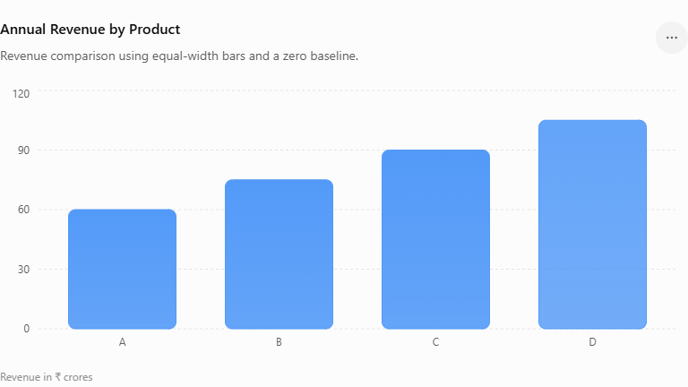

4. Possible consequences for investors
If investors rely on the misleading chart, they may:
- Overestimate Product D's performance.
- Believe that Product D generates substantially more revenue than it actually does.
- Invest more money in Product D based on a distorted comparison.
- Undervalue Products A, B, or C.
- Make incorrect decisions about company growth and future potential.
- Lose confidence later if the actual financial data does not match the visual impression.

Conclusion
Unequal bar widths violate the basic principle that bar size should represent data accurately and consistently. Using equal-width bars with a zero baseline ensures that the comparison reflects the actual revenue difference: Product D earns 75% more than Product A, not nearly three times as much.

Question 4: 3D Column Chart Distortion
An energy company reports renewable energy generation.
Source Energy (GWh)
Solar 450
Source Energy (GWh)
Wind 500
Hydro 550
Biomass 520
The analyst uses a 3D column chart with perspective effects. Due to the viewing angle, the Hydro bar appears almost 40% larger than Wind, although the actual difference is only 10%.
Tasks:
1. Explain why 3D charts can create misleading proportions.
2. Compare the perceived difference with the actual difference.
3. Recommend a better visualization.
4. Discuss the importance of avoiding visual distortion in sustainability reporting.

Given Data
Energy Source | Generation (GWh)
Solar | 450
Wind | 500
Hydro | 550
Biomass | 520

1. Why can 3D charts create misleading proportions?
3D charts can create misleading proportions because perspective, depth, shadows, and viewing angles change how large bars appear to the viewer.
In this case, the Hydro bar may appear much larger because of the 3D perspective, even though its actual value is only slightly higher than Wind. The additional visual depth can make a bar appear larger than its actual height.
Therefore, the viewer may judge the apparent size or area of a 3D object instead of comparing the actual bar heights.

2. Compare the perceived difference with the actual difference
Wind generation:
500 GWh
Hydro generation:
550 GWh
Actual difference:
550−500=50 GWh
Percentage difference relative to Wind:
500550−500​×100=10%
So, Hydro generation is 10% higher than Wind.
However, because of the 3D perspective, Hydro is perceived as almost 40% larger than Wind.
Comparison | Difference
Actual difference | 10%
Perceived difference | ≈40%
Thus, the chart exaggerates the actual difference by a large amount.

3. Recommended better visualization
A simple 2D bar/column chart is recommended.
It should have:
- Equal-width bars.
- A consistent scale.
- A zero baseline.
- No 3D effects or perspective.
- Clear labels showing GWh.
- Appropriate spacing between categories.
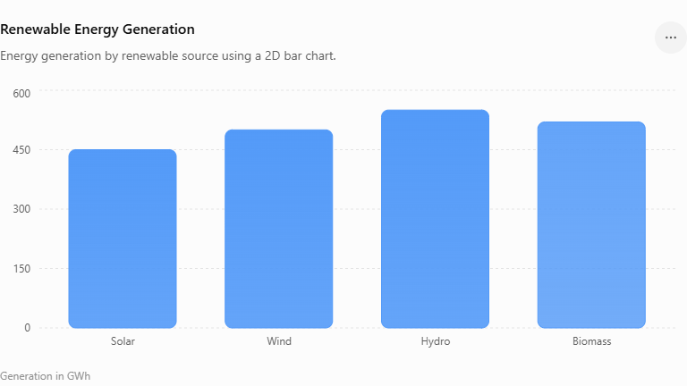
A 2D bar chart allows the viewer to compare the actual heights directly and prevents perspective from exaggerating differences.

4. Importance of avoiding visual distortion in sustainability reporting
Accurate visualization is particularly important in sustainability reporting because such reports are used by:
- Investors
- Government agencies
- Environmental organizations
- Company management
- Customers and other stakeholders
A distorted chart could make renewable energy performance appear better or worse than it really is. This can lead to incorrect investment decisions, misleading assessments of environmental progress, and reduced trust in the organization's sustainability reports.
Accurate charts help organizations maintain transparency, credibility, accountability, and trust.

Conclusion
The actual difference between Wind (500 GWh) and Hydro (550 GWh) is only 10%, but the 3D perspective makes it appear approximately 40% larger. A simple 2D bar chart with a zero baseline provides a more truthful representation and avoids visual distortion in sustainability reporting.
Question 5: Bubble Chart with Incorrect Scaling
A healthcare organization compares disease cases across five districts. District Cases
A 150
B 250
C 350
D 450
E 550
The analyst scales the bubble radius directly to the number of cases rather than scaling the bubble area. As a result, District E appears more than ten times larger than District A.
Tasks:
1. Explain why scaling the radius instead of the area is misleading.
2. Describe the correct method for proportional bubble sizing.
3. Suggest an alternative visualization suitable for this dataset.
4. Discuss the potential impact of this visualization on public health resource allocation.

Given Data
District | Disease Cases
A | 150
B | 250
C | 350
D | 450
E | 550

1. Why is scaling the radius instead of the area misleading?
In a bubble chart, viewers perceive the area of the bubble, not just its radius, as representing the magnitude of the value.
The area of a circle is:
A=πr2
If the radius is directly proportional to the number of cases, then the bubble area becomes proportional to the square of the number of cases.
For example:
150550​=3.67
So District E has only about 3.67 times as many cases as District A. But if radius is scaled directly to cases, the area ratio becomes:
(3.67)2≈13.44
Therefore, District E's bubble can appear more than 13 times the area of District A, greatly exaggerating the difference.

2. Correct method for proportional bubble sizing
The bubble area should be proportional to the number of cases.
Since:
A=πr2
the radius should be calculated as:
r∝Cases​
For example, choose a constant k:
r=kCases​
This ensures that doubling the number of cases results in twice the bubble area, rather than four times the area.
Thus:
Correct principle: Scale bubble area to the data value, not the radius.

3. Alternative visualization
A 2D bar chart would be more suitable for this dataset because there is only one variable

number of disease cases—and the main purpose is to compare districts.
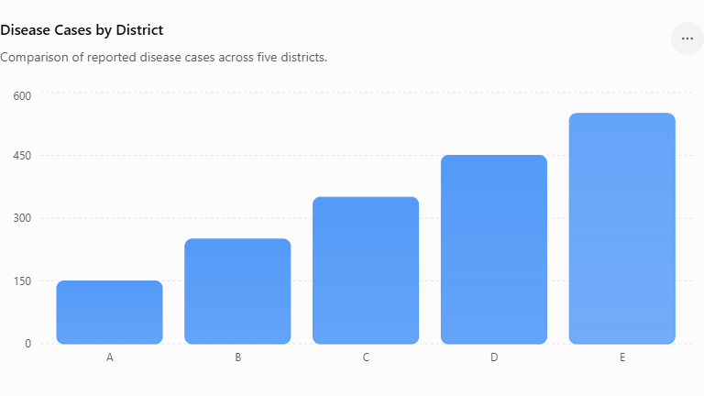
A bar chart provides a much more accurate and easy-to-read comparison than incorrectly scaled bubbles.

4. Potential impact on public health resource allocation
A misleading bubble chart could cause health authorities to overestimate the severity of disease in some districts and allocate resources incorrectly.
For example:
- District E may appear to require far more resources than District A than it actually does.
- Medical staff may be distributed based on exaggerated visual differences.
- Medicine and equipment could be allocated inefficiently.
- Emergency preparedness plans may be based on incorrect perceptions.
- Districts with fewer cases could receive insufficient attention or resources.
- Public health officials may make incorrect decisions about disease-control programs.

Conclusion
Scaling the radius directly to the number of cases exaggerates differences because bubble area increases with the square of the radius. The correct method is to make bubble area proportional to the number of cases, meaning the radius should be proportional to the square root of the cases. For this dataset, a bar chart is preferable because it provides a clear and accurate comparison for public health decision-making.

